**Coding Test-2: Python (List, Dictionary, String and Conditional)**

1. Print the largest value from three given integers.

Input:

10

20

5

Output:

20

1. Print the minimum value from three given integers.

Input:

10

20

5

Output:

5

1. Write a python program to calculate the grade of an exam. The exam mark will be given as input. Follow the UAP rule for grading.

Input:

74

Output:

A-

1. Write a python program to calculate the letter grade of an H.S.C exam. The exam mark will be given as input. Follow the standard rule for grading.

Input:

82

Output:

A+

1. Write a python code to determine odd or even.

Input:

5

Output:

Odd

1. Write a python code to determine negative or non-negative.

Negative numbers: -1, -2, -3, ……….

Non-negative numbers: 0, 1, 2, 3, ………

Input:

1

Output:

Non-negative

1. Write a program to check Leap year.

Following is pseudo code:

if year is divisible by 400 then is_leap_year

else if year is divisible by 100 then not_leap_year

else if year is divisible by 4 then is_leap_year

else not_leap_year

1. Given a list of 5 elements, swap two values of specified index.

Example:

List = [10, 5, 100, 4, 6]

Index 1 = 2

Index 2 = 4

Output:

List = [10, 5, 6, 4, 100]

Input:

Element 1: 10

Element 2: 5

Element 3: 100

Element 4: 4

Element 5: 6

Index 1: 2

Index 2: 4

Output:

[10, 5, 6, 4, 100]

1. Given a string of length 12, divide the string into 4 parts of length 3. Then swap the first part with the last part. Output the final string.

Example:

Given String: “ABCDEFGHIJKL”

4 parts of the string: “ABC”, “DEF”, “GHI”, “JKL”

Swap the first and last part: “JKL”, “DEF”, “GHI”, “ABC”

Output: ‘JKLDEFGHIABC’

1. Suppose you are going to start a Django Project with a group of 5 members. Now, you need to store the information (Name, ID, CGPA, Email_Address, and Contact_no) about the group members in some variables. Choose the appropriate data type to store these information.
2. Suppose you are going to start a Django Project and you have selected “Library Management System” as your project. Now, at some point you need to store information about books. Currently, you have 5 books. The information you are interested in are Name, Author’s name, Publication Date, Printing date and Price. Choose the appropriate data type to store these information.
3. Choose appropriate variables to store the following information.

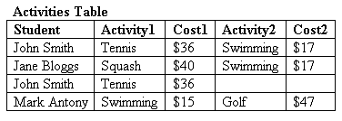

1. Choose variables of appropriate data type to store the following information.

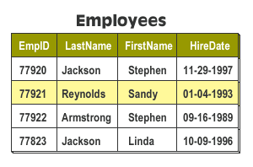

1. Choose variables of appropriate data type to store the information of the following table in a way that if someone inputs the ID, it will show all the information of that student.

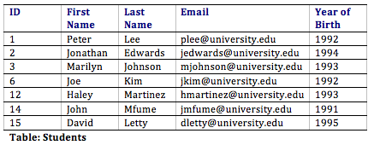

Input:

12

Output:

ID: 12, First Name: Haley, Last Name: Martinez, Email: hmartinez@univerity.edu, Year of Birth 1993

1. Choose variables of appropriate data type to store the information of the following table in a way that if someone inputs the EmployeeID, it will show all the information of that Employee.

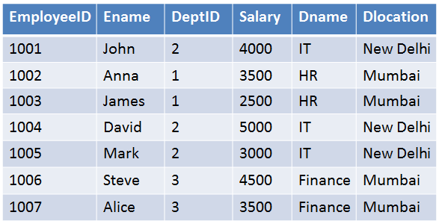

Input:

1002

Output:

Ename: Anna, DeptID: 1, Salary: 3500, Dname: HR, Dlocation: Mumbai